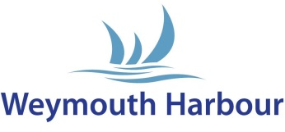

WEYMOUTH HARBOUR
CONTRACTOR DECLARATION

Contractor Information

Name: | Company:
Address: | Email:
Telephone: | Mobile:

Core Business (a brief description of the services you provide):

References (Please provide contact details for two customers or companies who are able to give us further information on your services, this information will be treated confidentially and used for this reference check only):

Contractors Declaration

I hereby acknowledge receiving and understanding Weymouth Harbour’s health and safety conditions and agree to abide by them at all times.

I declare the information I have provided in this form is accurate and true.

I agree to ensure that all of my employees, agents or subcontractors are fully aware of these requirements and shall agree to abide by them at all times.

I agree to comply with Health and Safety at Work Regulations.

I have provided Weymouth Harbour with a risk assessment and method statement relevant to any work being undertaken.

I will ensure that any dangerous/combustible materials /liquids are safe for the work to be undertaken?

Signature of contractor ………………………………………. Date …………………………….

Please print name ……………………………………………

We are committed to protecting your personal data; our Privacy Notice can be found on our website or please ask for a copy.

Harbour Masters Office, 13 Custom House Quay, Weymouth. Dorset DT4 8BG
Email: weymouthharbour@dorsetcouncil.gov.uk

