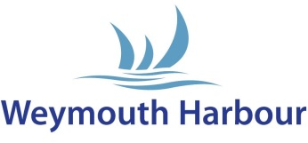

WEYMOUTH HARBOUR – REGISTERED CONTRACTOR APPLICATION

Contractor Information:

Name: | Company:
Address: | Email:
Telephone: | Mobile:

Core Business (a brief description of the services you provide)

References (Please provide contact details for two customers or companies who are able to give us further information on your services, this information will be treated confidentially and used for this reference check only)

Contractors Declaration

I hereby apply for registration as an approved contractor at Weymouth Harbour
I acknowledge receiving and understanding Weymouth Harbours conditions regarding health and safety and should my application be successful agree to abide by them.
I declare the information I have provided is accurate and true.
I agree to ensure that all of my employees, agents or subcontractors are fully aware of these requirements and shall agree to abide by them at all times

Signature of contractor ………………………………………. Date …………………………….

Please print name ……………………………………………

Application Checklist to be completed by Weymouth Harbour

All contractors must comply with Health and Safety at Work regulations | Yes No
All contractors must provide Weymouth Harbour with a risk assessment and method statement relevant to the work being undertaken. | Yes No
Is the area clear of dangerous/combustible materials /liquids and safe for work to be undertaken? | Yes No

To be completed by Weymouth Harbour

Permission Granted:  | Signature: | Date:
Permission Refused: 

We are committed to protecting your personal data; our Privacy Notice can be found on our website or please ask for a copy.

Harbour Masters Office, 13 Custom House Quay, Weymouth. Dorset DT4 8BG
Email: weymouthharbour@dorsetcouncil.gov.uk

